Shoppick

Requirement specification

|  |  |
| --- | --- |
| Student Number | Name |
|  |  |
|  |  |
|  |  |
|  |  |

**Contents**

**1. Preface1**

1.1 Objectives2

1.2 Readership2

A. User Requirements3

B. System Requirements3

1.3 Document Structure2

A. Preface3

B. Introduction3

C. Glossary3

D. User Requirement Specification3

E. System Architecture3

F. System Requirement Specification3

G. System Models3

H. System Evolutions3

I. Appendix3

J. Index3

K. Reference3

**2. Introduction7**

2.1 Objectives7

2.2 Needs7

A. The advertisement of fashion brands7

B. Problems of the advertisement for companies7

C. Problems of the advertisement for consumers7

D. Shopping methods7

2.3 The resolution: Shoppick 7

2.4 Expected effects7

A. Effects to the companies7

B. Effects to the users/consumers7

**3. Glossary7**

3.1 Objectives2

3.2 Definitions of terms2

A. Terms for people3

B. Terms related to the service3

1. Preface

1.1 Objectives

In this section we summarize the structure and the specifics of this document on the level that each groups of expected readers will understand.

1.2 Readership

This is divided into two parts user requirements and system requirements according to the readers. User requirements, often referred to as user needs, describe what the user does with the system, such as what activities that users must be able to perform. System requirements are the building blocks developers use to build the system.

A. User requirement

User requirement considers are statements in natural language plus diagrams of the services the system provides and its operational constraints. Written for system end-user, client-manager, client engineers, contractor-mangers, system architects.

B. System requirement

System requirement is a structured document setting out detailed descriptions of the system’s functions, services and operational constraints. Defines what should be implemented so may be part of a contract between client and contractor.

1.3 Document Contents

This document is constituted in eleven categories. Categories include Preface, Introduction, Glossary, User Requirement Definition, System Architecture, System Requirement Specification, System Models, System Evolutions, Appendix, Index, Reference. Each category is as followed.

A. Preface

Preface talks about the expected readers, the abstract structure of this document and the summary of each categories.

B. Introduction

Introduction is about the value of our system ‘Shoppick’. It includes the needs of the customers and what difference and strength our system has compared to other systems/software. It also presents the expected effects of the software.

C. Glossary

Glossary will be explaining the technical terms this document will be using. It is target to readers without any professional knowledge.

D. User Requirement Specification

The user requirement specification talks about the service ‘Shoppick’ will be offering. Functional and non-functional requirements will be both described. It will be explained in natural language on the level that even the readers without any background knowledge can understand the concept. The part where it is hard to explain with the natural language will be replaced with objects such as diagrams or tables.

E. System Architecture

System architecture will be showing the abstract summary of the architecture of ‘Shoppick’. It also describes how the functions consisting the system is distributed.

F. System Requirement Specification

System requirement specification will be a more detailed version of user requirement specification. It also shows the detailed scenarios of the process resulted while using ‘Shoppick’ for the sake of easier understanding and concrete idea of the system.

G. System Models

System models present the internal and external relations between the system and the components. Especially it is focused on the inputs and outputs and the operation process of the database. Most of the explanations will be made by using objects.

H. System Evolutions

System evolution is about the presumptions made after the technological advancements. This helps the system developers assume the changes that can be made in the future.

I. Appendix

Appendix will be describing the back-end process along with most details that has be omitted from the contents above.

J. Index

The index of the objects used in this document

K. Reference

References used while making ‘Shoppick’

2. Introduction

2.1 Objectives

This chapter explains the needs and how ‘Shoppick’ outperforms other systems on the market.

2.2 Needs

A. The advertisement of fashion brands

Fashion has been around for centuries and since the start of the industrial age when clothes have been manufactured in enormous volumes, clothes have been something people has been using to define themselves. There has been increasing amount of fashion brands and designers making their own clothes up to recent days and this is evidently a forever growing market.

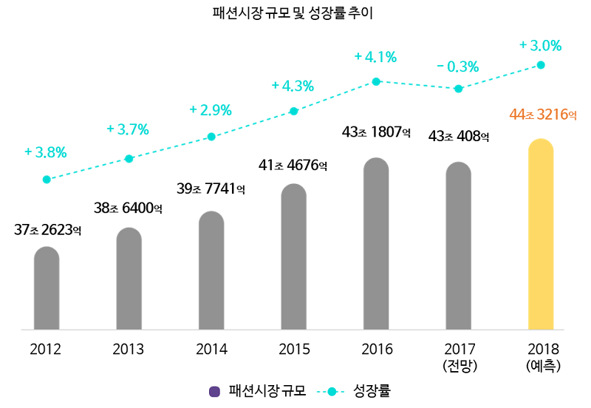

Chart 1. The growth rate of fashion market

Consumers nowadays have so many different brands of clothes to choose from, so it has been made essential for the brand/shop owners to do an excelling job on marketing or advertising their clothes. Direct advertising has been the mainstream until media developed and now companies are using indirect advertising way more than the direct ones. These advertisements have been started from magazines to celebrities coming out on TV shows with their clothes on and in recent days to influencers in social network services.

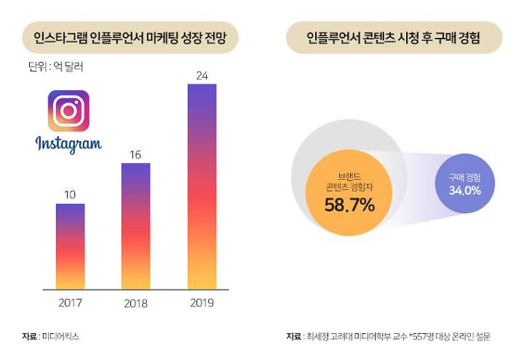

Chart 2. The effects of influencers

B. Problems of advertisements for companies

As much as fashion brands exist in the world so does advertisements. However, while there are variety of brands making similar clothing, consumers can have difficulties to find the exact clothing that was advertised on media. It would be a loss for the companies that the money put on advertisements aren’t coming back as profits.

C. Problems of advertisements for consumers

Consumers who are interested in fashion tend to get curious about what their bias celebrities and influencers are wearing. It is not often that we meet with a question on the internet what specific clothing someone is wearing in that show or post. If someone doesn’t answer for the companies, it is a loss of a potential customer. Consumers and fashion enthusiasts need a system that they can use real-time.

D. Shopping methods

There are so many shops in the world outdoors and on-line. It is hardly possible for people to find what shops fit their style. It is time consuming and just might end without any profit.

2.3 The resolution: Shoppick



Picture 1. Shoppick logo

Shoppick has two major functions.

Finding the exact or the closest clothes to given picture

Recommending on-line shops according to the user style information gathered through the SNS

Shoppick can find the closest clothes to the picture taken or given by the users. First Shoppick holds clothing information from the sellers and makes a huge database. Later whenever the user uses the service matches them with the pictures given from the customers.

When a user first logs in to Shoppick, they must log-in with their SNS account and is recommended to use the account they use the most. Shoppick also requests permission to use the pictures uploaded in the user’s account. With the data Shoppick forms up to three style tags and saves it. Then the user is recommended with the tags matching their individual tags.

2.4 Expected effects

A. Effects to the companies

Companies wouldn’t be wasting money on their advertisement and doesn’t have to keep a team running to give answers to the questions that pop up in the internet about their clothes that the celebrities or influencers are wearing. They also would get to know which indirect advertisement was the most efficient and which style the users prefer.

B. Effects to the users/customers

The users trying to follow their bias’s style wouldn’t have any difficulty finding out the exact brand and clothes, style their bias is wearing. They would get the exact information as soon as they hit a picture into Shoppick.

Users not knowing what to wear or not knowing where to buy the clothes they want can easily have access to their wants while Shoppick gives them a recommendation according to the data gathered from the individual’s SNS.

3. Glossary

3.1 Objectives

In this part we define the terms used in this document. It will be at the eye level of readers that doesn’t have any background knowledge of this area. Hence most of the terms will be covered.

3.2 Definitions of terms

A. Terms for people

|  |  |
| --- | --- |
| Terms | Definition |
| Company owners / Sellers | People who are owning a shop or involved in producing or selling clothing |
| Customers | People who are trying to or are buying clothing |
| User(s) | People who are using ‘Shoppick’ |
| Administrator(s) | People or an individual operating ‘Shoppick’. They oversee management and maintenance of the server for the application. |
| Developer(s) | People or an individual who are involved in developing or evolving ‘Shoppick’. |

Table 1. Terms of people

B. Terms related to the service

|  |  |
| --- | --- |
| Terms | Definition |
| Login |  |
| Logout |  |
| Search |  |
| Tag |  |
| Category |  |
|  |  |

Table 2. Terms related to service